PROBABILITY
Pearson Edexcel - Tuesday 21 May 2019 - Paper 1 (Non-Calculator) Foundation Tier

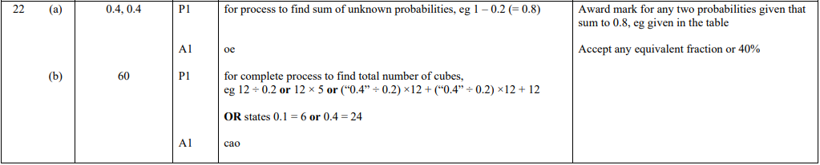

Pearson Edexcel - Thursday 6 June 2019 - Paper 2 (Calculator) Foundation Tier

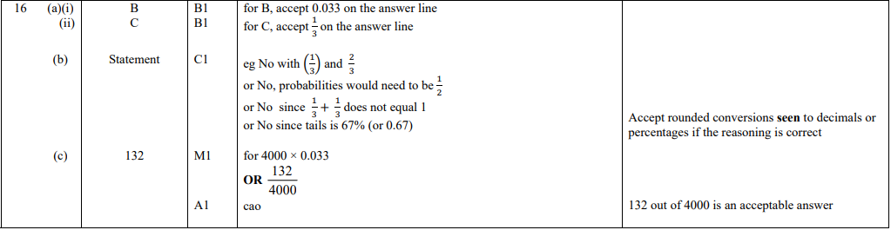

Pearson Edexcel - Tuesday 12 June 2018 - Paper 3 (Calculator) Foundation Tier

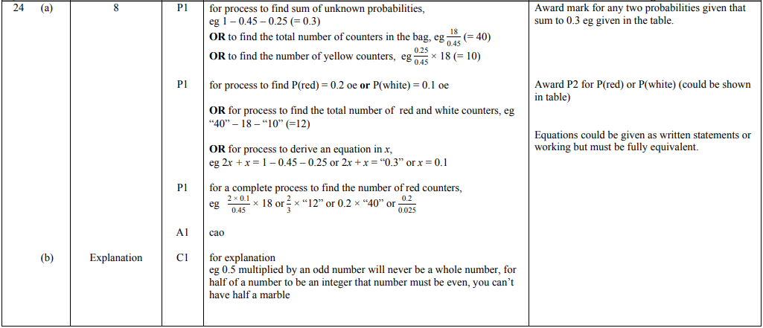

Pearson Edexcel - Monday 6 November 2017 - Paper 2 (Calculator) Foundation Tier

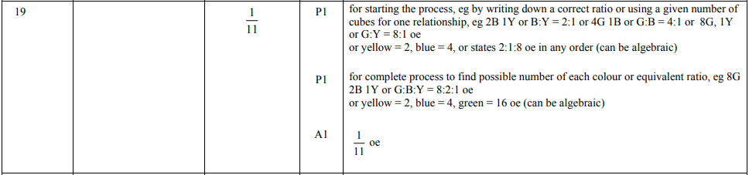

Pearson Edexcel - Wednesday 8 November 2017 - Paper 3 (Calculator) Foundation Tier

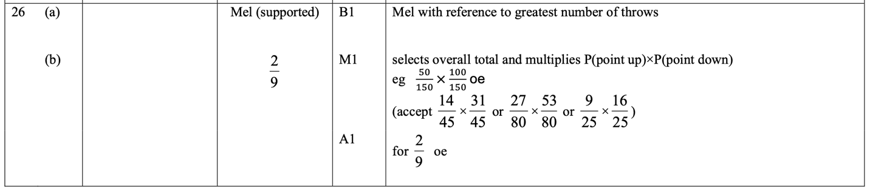

Pearson Edexcel – Specimen 2 - Paper 1 (Non-Calculator) Foundation Tier

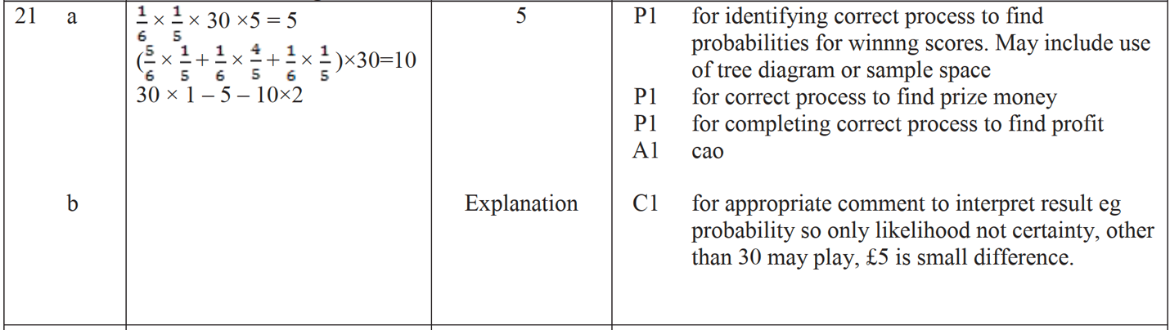

Pearson Edexcel – Specimen 2 - Paper 3 (Calculator) Foundation Tier

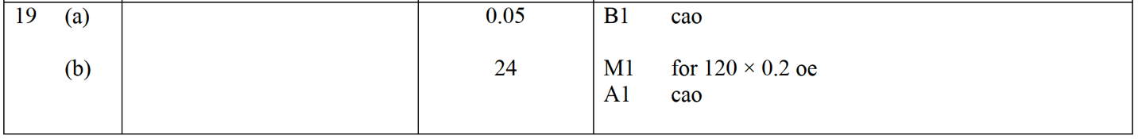

Pearson Edexcel – Specimen 1 - Paper 1 (Non-Calculator) Foundation Tier

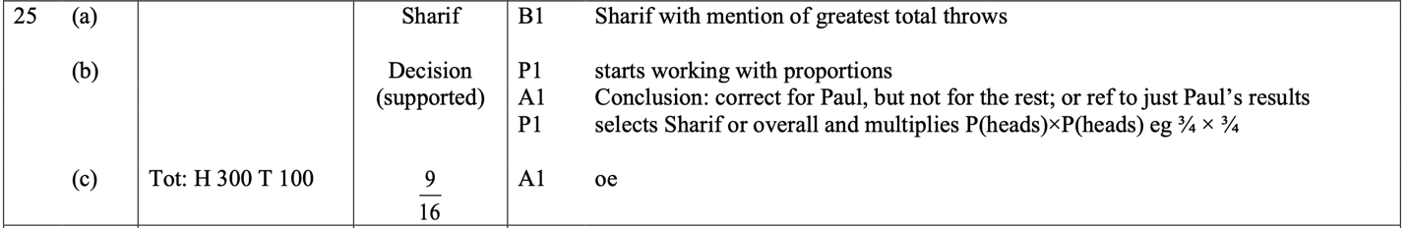

OCR – Tuesday 03 November 2020- Morning - Paper 1 (Calculator) Foundation Tier
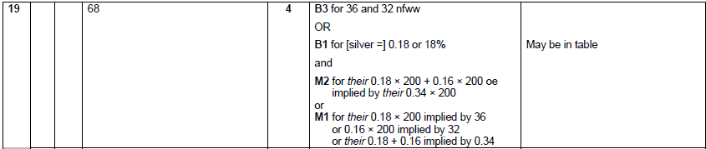

OCR November 09 November 2020- Morning (Calculator) Foundation Tier
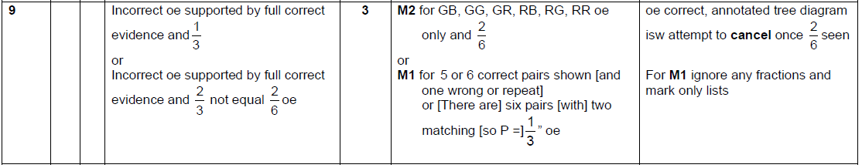

OCR Monday 11 November 2019 – Afternoon (Calculator) Foundation Tier

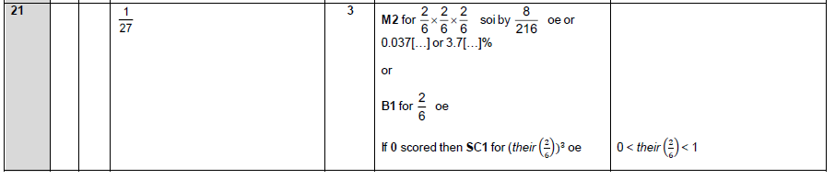

OCR Thursday 6 June 2019 – Morning (Non-Calculator) Foundation Tier
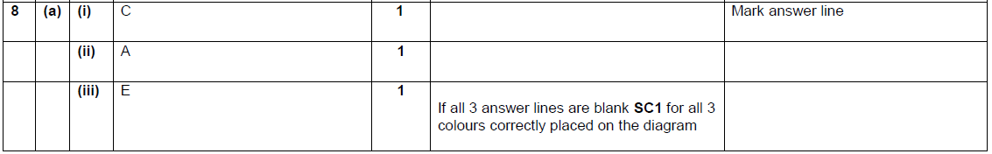

OCR Tuesday 11 June 2019 – Morning (Calculator) Foundation Tier
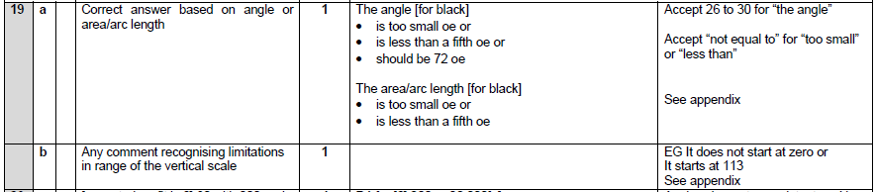

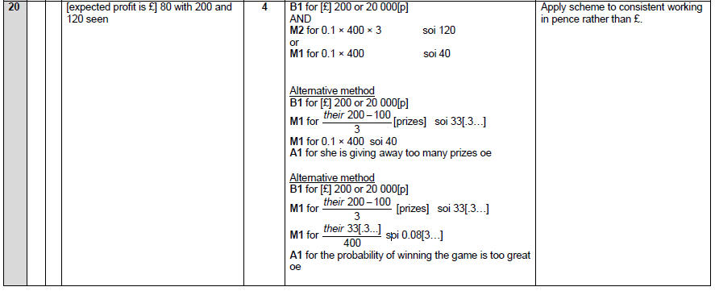

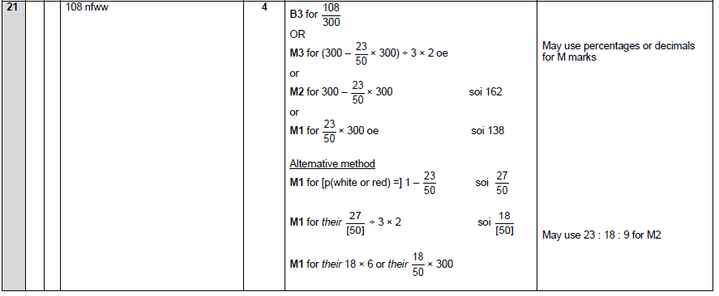

OCR Monday 24 May 2018 – Morning (Calculator) Foundation Tier
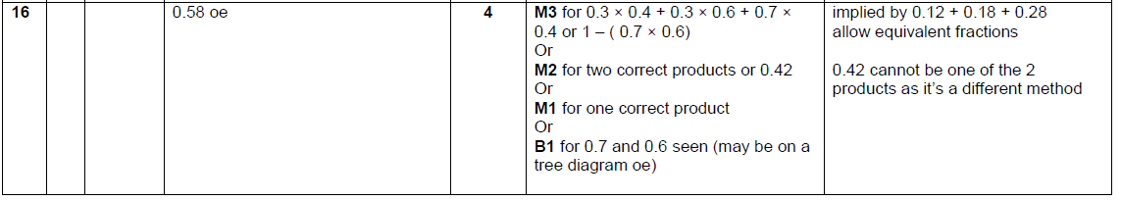

OCR Thursday 7 June 2018 – Morning (Non Calculator) Foundation Tier

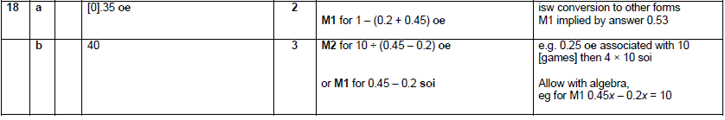

OCR Thursday 8 June 2017 – Morning (Non - Calculator) Foundation Tier

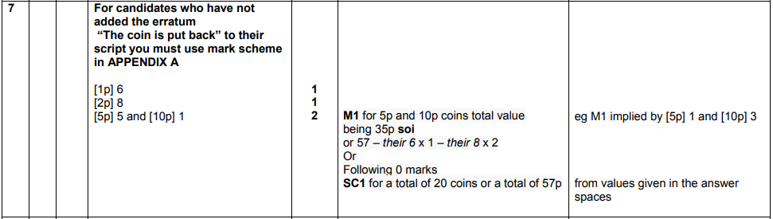
OCR Tuesday 13 June 2017 – Morning (Calculator) Foundation Tier

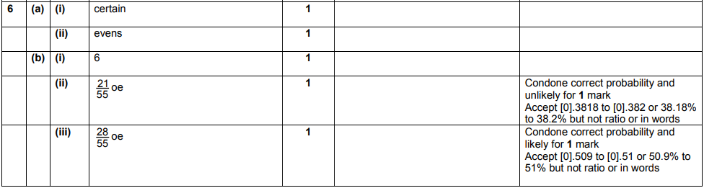

OCR Tuesday 13 June 2017 – Morning (Calculator) Foundation Tier

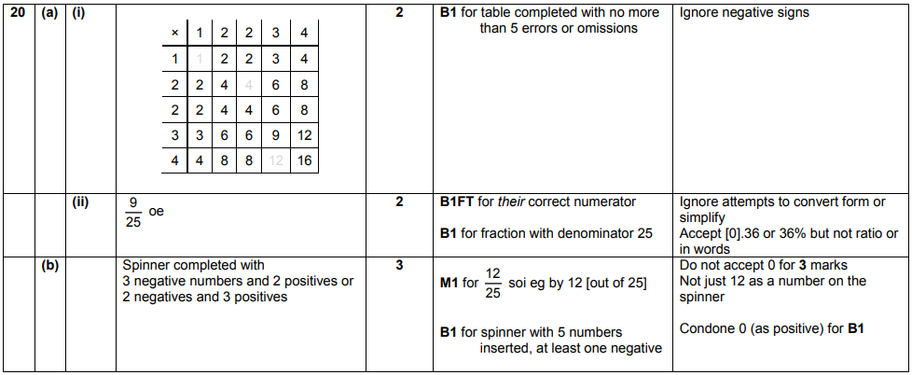
OCR Sample Question Paper 1 – Morning/Afternoon (Calculator) Foundation Tier

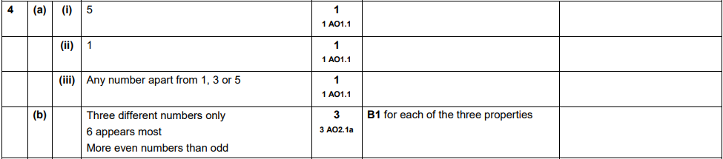

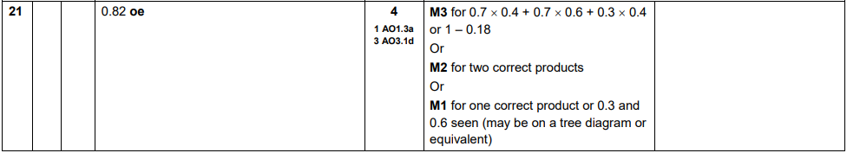

OCR Sample Question Paper 2 – Morning/Afternoon (Non - Calculator) Foundation Tier

AQA Monday 12 November 2018 – Morning (Calculator) Foundation Tier

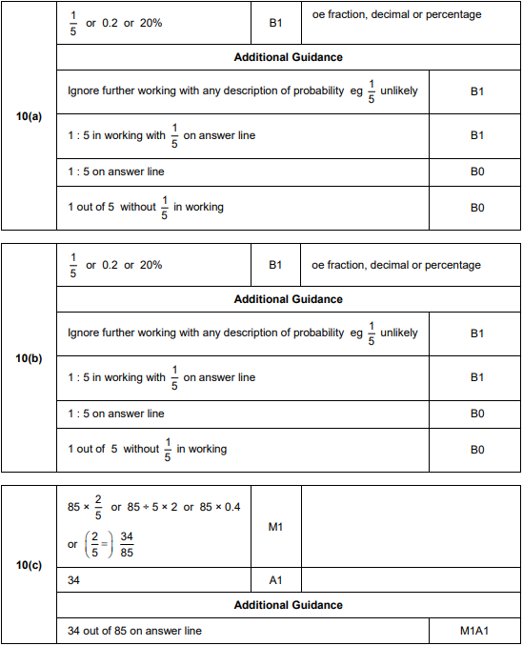

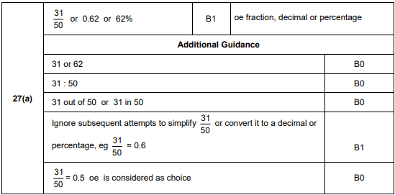
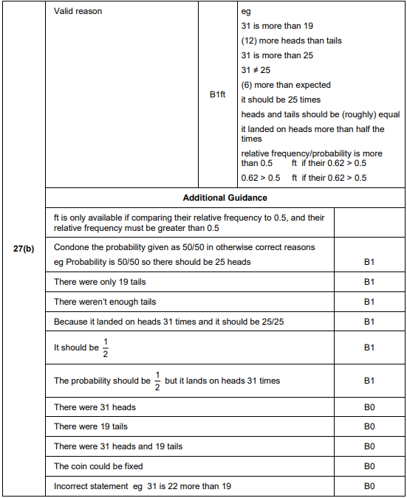

AQA Thursday 8 June 2017– Morning (Calculator) Foundation Tier

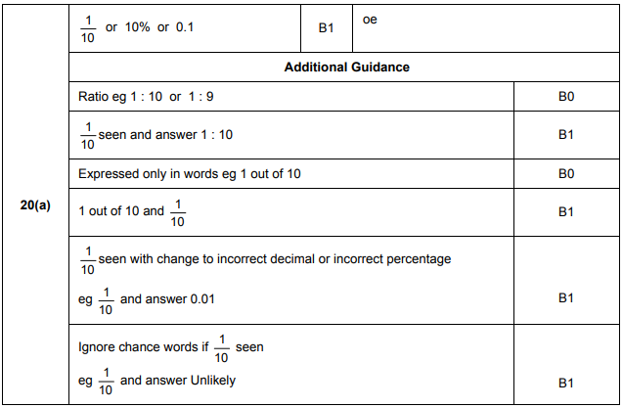

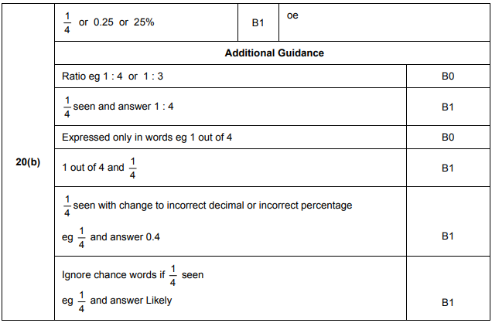
AQA Tuesday 13 June 2017 Morning– Morning (Calculator) Foundation Tier

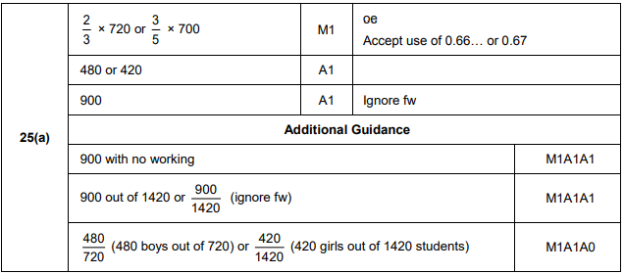
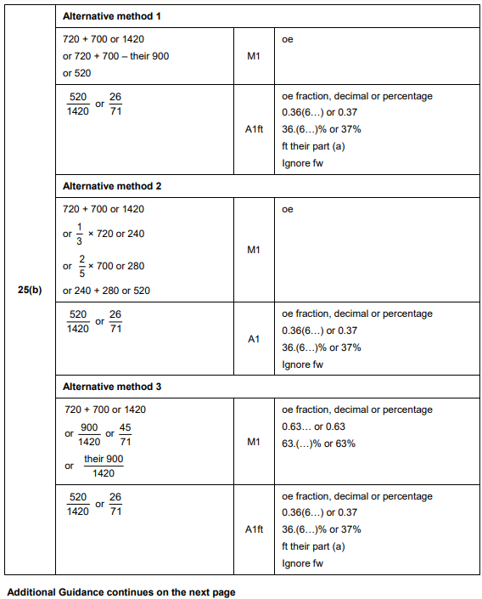
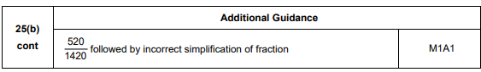

AQA Sample Paper 2– Morning (Calculator) Foundation Tier

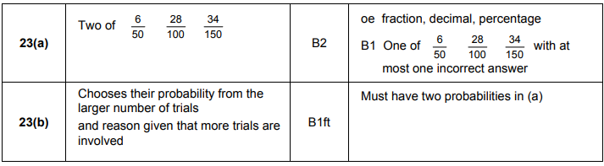
AQA Sample Paper 3– Morning (Calculator) Foundation Tier

